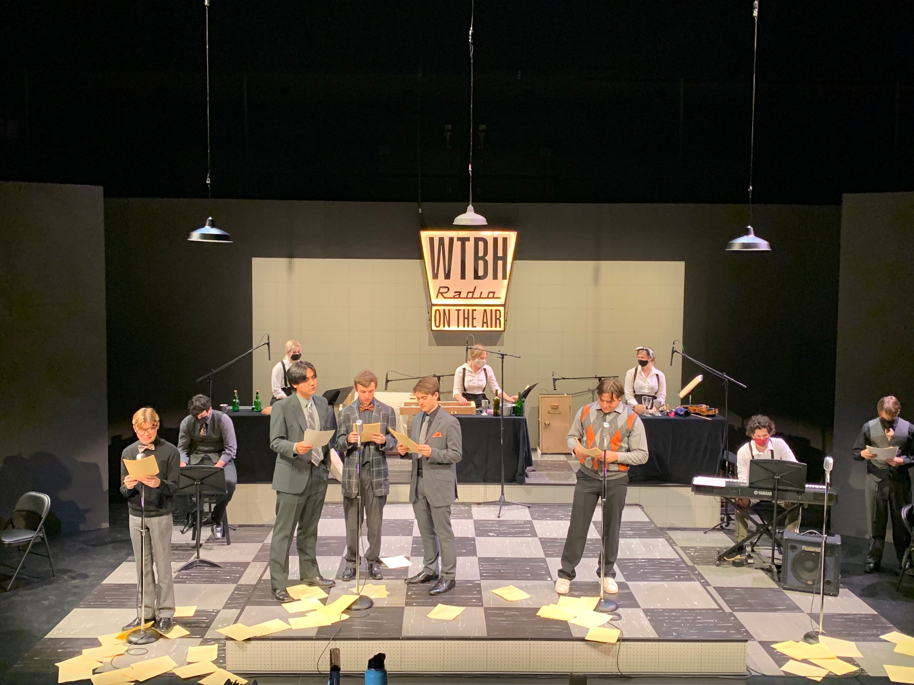

Theater Department
Spring 2022 Courses

THTR 108 World Theater
A survey of plays from different eras and performance traditions in diverse cultures; introduces students to evaluating, discussing, and writing about theater from a global perspective. (GM2, H) Michael O’Neill. TR 2:45-4:00PM, FC Limburg Theater.

THTR 120-01 PRACTICUM
THTR 120-02 PRACTICUM
¼ Course credit for participation in Acting in Productions

THTR 121-01
THTR 121-02 PRACTICUM
¼ Course credit for participation in Tech in Productions

THTR 208 Theater and Diversity
This course examines live and streaming theater productions that address issues of gender, race, ethnicity sexuality, class, and accessibility, and explores the extensive inclusivity struggles that face those who currently work in the theater. The course also explores creative strategies that can be used to mitigate the lack of diversity often evident in classical theater. (GM1, H, V, W) Mary Jo Lodge. MW 11:00AM-12:15PM, WAC 248 Studio Theater.

THTR 222 Collaborative Process
Through lecture, discussion, performances, hands-on experience, films, guest artists, and readings of primary texts, this course intends to introduce the student to the principles of visual design as applied to scenic, lighting and costume design for the theatre. (H) Erin Hopwood. MWF 10:00-10:50AM, WAC Buck Hall 102.

THTR 230 Acting II: Violence and Intimacy
This workshop course extends beyond basic acting and improvisation training to offer a more in depth, intermediate level study of the craft of acting. Students will utilize exercises, and detailed script analysis as they build and develop characters. Students will learn the protocols of safety and consent while working on scenes that involve intimacy and/or stage violence. In this course, students will perform in a range of scenes and monologues, including works drawn from the early Modernist plays of Ibsen, Strindberg and Chekov. Class projects will include performances of scenes and monologues; rehearsals of performance projects both inside and outside of class; attendance at a variety of performances and research and analytical papers and presentations. Prerequisite: Theater 130 or permission of the instructor. (H) Brad Lemons. TR 11:00AM-12:15PM, WAC 248 Studio Theater.

THTR 270: Topics: Arts Management
Careers in arts management exist at the intersection of business and the arts where creativity and pragmatism combine to support the artists and art that invigorate our community and lives. Throughout the semester we will examine the structure of arts organizations, the people who staff them, and how they fit within the broader cultural, political, and economic world. (H) Alex Owens. TR 9:30-10:45AM, WAC Buck Hall 102.

THTR 280 Speaking Power
Intending to be a lawyer? Public Relations in your future? Need to master the arts of persuasion? Feeling unconfident while speaking in public? Planning on any career in business that requires speaking with authority? You’ll need to become proficient at rhetorical technique. This course will focus on effective speaking strategies for life and for professions, including: analyzing effective speeches; writing and delivering persuasive rhetoric; building confidence and authority; mastering argument techniques; fostering “presence” for public performances; and channeling anxiety to build focus. (H, V, W) No pre-requisites. Kathleen Swann-Fisher. MWF 1:10-2:00PM (01), 2:10-3:00PM (02), OECHSL 211

THTR 369 Theater Artists in Focus: Irish Drama
Read and watch performances of plays by Samuel Beckett, Sean O’Casey, Brian Friel, Tom Murphy, Frank McGuinness, Martin McDonagh and other Irish dramatists who have shaped twentieth and twenty-first century drama. (W) Michael O’Neill. TR 1:15-2:30PM, FC Limburg Theater

THTR 372 Internship Instructor Signature THTR 400 Senior Project Dept. Head Signature
THTR 390 Independent Study Instructor Signature THTR 495 Thesis Dept. Head Signature

MUS 272/372: "Experiencing Opera: Gilbert and Sullivan": An introduction to the comic operas of W.S. Gilbert and Sir Arthur Sullivan. Enrollees will read the librettos and discuss the themes of a select number of the operas and prepare select scenes for performance: acting, singing, dancing, stage management, etc. (H, GM2) Pre-req: none

For those interested in developing a minor that focuses on Arts Management, the new Organizational Studies Program will help prepare you for such a future: courses available that count toward the minor (check that you have the pre-requisites): A&S 220 Who Gets What and Why; A&S 231 Anthropology of Education; A&S 245 Mass Communications and Society; Econ 342 Public Finance; Econ 358 Corporate Governance and Ethical Responsibility; Econ 361 Marketing Research; Econ 406: Personnel Economics; THTR 270 Arts Management.

